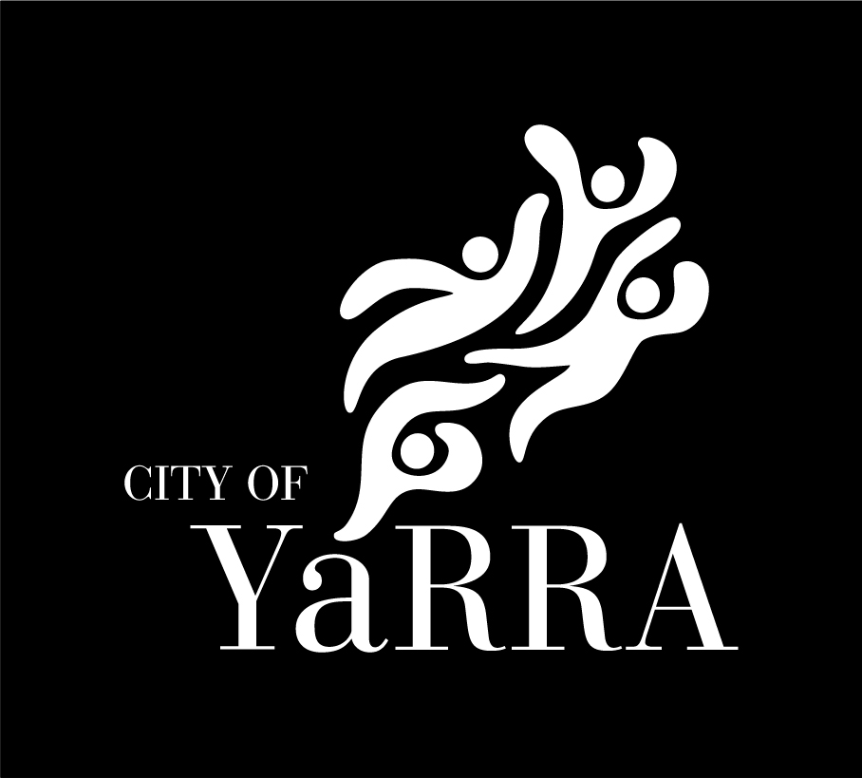
Social Justice Charter

Acknowledgement of Country

Yarra City Council acknowledges the Wurundjeri Woi Wurrung people as the Traditional Owners and true sovereigns of the land now known as Yarra. We acknowledge their creator spirit Bunjil, their ancestors and their Elders. We acknowledge the strength and resilience of the Wurundjeri Woi Wurrung, who have survived European invasion and never ceded sovereignty. We also acknowledge the significant contribution made by the many other Aboriginal and Torres Strait Islander people to life in Yarra.

We acknowledge that Fitzroy and Collingwood are areas of special significance to Aboriginal and Torres Strait Islander people—as the cradle of Aboriginal and Torres Strait Islander affairs in Victoria, the birthplace of important Aboriginal and Torres Strait Islander organisations, the centre of political activism and a meeting place for Aboriginal and Torres Strait Islander people to link in with family, community and services. We acknowledge the role played by past federal and state government policies in the social and cultural dispossession of Aboriginal and Torres Strait Islander people—and the dispossession of land—which has caused the current disadvantages faced by many Wurundjeri Woi Wurrung Aboriginal and Torres Strait Islander people. And we believe that having an awareness of, and taking steps towards, mending this disadvantage is the shared responsibility of all residents in the City of Yarra.

Council pays its respects to all in the Wurundjeri Woi Wurrung, Aboriginal and Torres Strait Islander community and Elders from all nations here today—and to their Elders past, present and future.

Statement of Commitment

The City of Yarra is a vibrant and diverse municipality. It is the traditional lands of the Wurundjeri, and a place of special significance for the broader Aboriginal community. The City of Yarra is also home to diverse communities, something that Council is proud of and recognises as an asset.

Council has an important (and legally required) role to play in upholding and protecting its diverse population’s human rights. Council will actively work to reduce barriers so that all residents can participate in community and access services and information regardless of age, gender, sex, sexuality, income, education, cultural background, language skills, religion or disability.

Council also recognises that the community continues to evolve and the strengths and barriers of diverse groups will also continue to change. This Charter is a commitment for Council to continue to understand these changes and to respond accordingly.

Our strong commitment to achieving social justice is articulated by our being signatories to a number of international Human Rights treaties. Further, we are bound by the Charter of Human Rights and Responsibilities Act 2006 (Vic) to act compatibly with human rights, and to consider human rights when developing policies, making laws, delivering services and making decisions.

We are proud to be signatories to this Charter which outlines how we will protect our residents’ human rights by promoting social justice principles and addressing the social justice issues most associated with, and reflective of, our community.

Signatories MAYOR AND CEO

Social Justice – Guiding Principles for Yarra

The Charter of Human Rights & Responsibilities 2006 (Vic) sets out 20 human rights under four key areas – Freedom, Respect, Equality and Dignity. Human rights and social justice are complementary concepts. Social justice is based on the concepts of human rights and equality (equal rights and equal opportunity for all), and can be defined as the way in which human rights are attained and protected.

Human rights are based on dignity, equality and mutual respect – regardless of nationality, religion or beliefs. Social justice principles work together to manage inequities in terms of human rights based on cultural, social, economic and political factors. For this reason, social justice principles aim to provide a fair allocation of resources and entitlements without discrimination.

Yarra Council undertook consultations with community, stakeholders and Council staff to gather information about what was important to them. Analysis of responses showed that people in Yarra were passionate about human rights and social justice issues, cited often as a drawcard to this municipality, whether to live, work or play.

The data revealed the following as the most critical social justice principles needed to ensure protection of human rights in Yarra.

The guiding Social Justice principles are:
- Access - All services, programs and facilities should be available and usable for all people free from any form of discrimination;
- Equity - Distribution of economic, social and political resources in ways that are not restricted by age, gender, sex, sexuality, race, ethnicity, religion, ability, or income;
- Rights - Equal effective legal, industrial and political rights; and,
- Participation - Opportunities for real participation by all in the decisions which govern their lives.

Social justice is the underlying principle for peaceful and prosperous communities. By upholding the principles of social justice, we remove barriers that people face because of gender, age, race, ethnicity, religion, culture or disability. A “just” municipality is by definition an inclusive and diverse municipality.

Council Role – Our Framework for Action

Ensuring the human rights of our residents are protected is an ongoing process. Yarra Council commits to work together with community to achieve social justice for all and is legally obliged to uphold and protect those rights.

To sustain the principles of social justice will require a culture where staff are fully engaged with the issues, planning and implementation (day to day actions), and compliance with relevant legislation.

We will create a culture in the City of Yarra where people respect and understand an individual’s human rights by engaging all (internally at Council/externally with our community) on the principles of social justice and our commitment to them.

We will ensure that social justice principles are embedded in all planning processes and in the development of policies, strategies and provision of services. Actions attached to strategies need to implement the social justice principles.

The Social Justice Charter acts as an umbrella document for all future plans, policies and frameworks. It is a lens which will guide the development of policies, processes and programs. Yarra currently employs a human rights-based approach in policy development. The Charter will ensure this approach is formalised, is responsive to community needs and has longevity.

We will work continuously to ensure our services, programs, communications, employees, contractors and sub-contractors comply with all obligations set out in law and by the treaties to which we are signatories.

Social Justice in Yarra – Priority Areas

Council has historically been proactive in addressing a number of areas that are high on the national and international human rights agenda – including indigenous rights, the rights of refugees and people seeking asylum, and access and inclusion for people with disability.

Yarra will continue to ensure that its large indigenous community is acknowledged as the Traditional owners, that Yarra is a safe place for refugees and people seeking asylum, and that access and inclusion for all is a Council wide focus. This work is done via policy positions, strategic planning, advocacy and program delivery.

Council remains committed to protecting the rights of our more vulnerable residents, and those more likely to be at risk of discrimination.

Discrimination is not always experienced because of one attribute such as age, disability, gender, sexual orientation or race. Sometimes it is the intersection of attributes that leads to the experience of discrimination.

We need to recognise the intersection – and therefore the complexities – of different components of people’s identities, and that discrimination can be multi-layered.

While not an exhaustive list (and recognising the continuing evolution of communities), the following groups have been identified as more likely to face issues related to social justice:

- Aboriginal and Torres Strait Islander people
- Children and younger people
- Older people
- People with Disabilities
- People from Culturally and Linguistically Diverse Backgrounds
- People of diverse faiths and religions
- People from the LGBTIQ community
- People experiencing homelessness
- People on low incomes
- People who use drugs
- People experiencing mental health issues
- Refugees and people seeking asylum
- Women

How We Uphold Social Justice Everyday

By understanding and addressing social justice principles, we will build a culture where human rights are a priority in our community. Strategies to allow access for all, equity in provision of services, ensure rights are met, and create an environment where participation is possible are outlined below. Each area has examples of actions (again, not an exhaustive list) which can be considered when developing a policy or plan, or delivering a service or program.

Principle | Examples
Access | - Advisory groups and consultative committees which reflect our diverse community.  - Accessible consultation and research programs prior to the development of a program or service.  - Accessible communications (i.e. print, audio, simple English, translations etc), including using a diversity of communication channels.  - Ensure venues and transport are accessible.  - Universal design principle a foundation of planning capital works.  - Remove “barriers” to information and services eg over-reliance on web-based interaction precludes many groups in the community.
Equity | - Ensure “Terms of Reference” for committees/ meetings confirm commitment to social justice.  - Induction and employee training programs highlight social justice charter.  - Use of public spaces (eg. footpaths, parks etc) need to be equitable for all to use facilities.  - Develop an understanding of the complexities of managing the needs of more than one marginalised group, and the intersectionalities at play.  - Look at what institutionalised barriers are in place and what could be done to deconstruct them.  - Community grants available and allocated to a diverse representation of our community.  - Development of a fee structure for services such as child care etc which acknowledges families on low incomes.
Rights | - Education on human rights for staff, including obligations and requirements.  - Advocacy by “calling out” – educate staff on the appropriate way to deal with discriminatory practices at Council.  - Develop information / scripts which challenge intolerant attitudes, nurturing more compassion and empathy.  - Council engages in advocacy programs within the community, “standing up” for vulnerable groups.
Participation | - Partnering with diverse groups to help plan and execute programs and initiatives, especially those involving diverse groups.  - Facilitating community members to influence Council strategies and policies.  - Develop understanding of who all the relevant groups are, listen to the “unheard” voices, to bring different perspectives to the table.  - Utilise existing networks and advisory groups to promote information and to gather information.  - Ensure membership on panels, speakers at events etc is a diverse representation.

