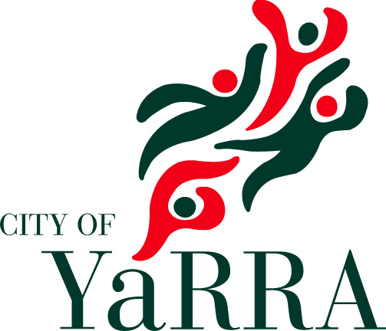

Graffiti Management Framework:
Policy & Strategy
2019-2022

Contents

1 Purpose 4
2 Scope 4
3 Definitions 4
4 Council Policy 11
4.1 Preamble 11
4.2 Policy 12
4.2.1 Graffiti Removal 12
4.2.2 Place Management 15
4.2.3 Education & Capacity Building 15
4.2.4 Promotion 15
4.2.5 Planning and Enforcement 15
4.2.6 Monitoring and Evaluation 15
5 Consultation 17
5.1 Related documents and attachments 17
6 Graffiti Management Strategy 2019-2022 18

Purpose
This document outlines Council’s whole-of-community approach to graffiti management within the municipality.

Scope
The whole-of-community approach centres on building partnerships between Council and those who reside, work or own property within the City of Yarra.
The whole-of-community approach includes a set of key outcome areas for graffiti management comprising:
- graffiti removal
- place management
- education and capacity building
- promotion
- planning and enforcement
- monitoring and evaluation.
This policy applies to all Officers and Councillors of the City of Yarra, and guides Councils work from 2019 – 2022.

Definitions
In alphabetical order, the following section lists the terms which are commonly used within the context of illegal graffiti management. This list is not exhaustive.
Crime Prevention Through Environmental Design
Crime Prevention Through Environmental Design (CPTED) is an approach to crime prevention that takes into account the relationship between the physical environment and the users of that environment. The use of design principles to address issues of crime and antisocial behaviour has been associated with best practise initiatives both internationally and throughout Australia.
An example of CPTED is Council’s use of treatments to manage graffiti, whereby a mural or other type of legal street art is used to improve the appearance of outdoor walls and spaces covered in tagging and as a result, reduce the chance of future incidents occurring.

Examples of treatments on traffic signal boxes:
[INSERT NEW PHOTO]
Criminal Justice Diversion Program
The Criminal Justice Diversion Program is governed the Criminal Procedure Act 2009. The Program provides mainly first time offenders with the opportunity to avoid a criminal record by undertaking conditions that benefit the offender, victim and the community as a whole.
The offender benefits from the program by avoiding an accessible criminal record, by receiving appropriate assistance through rehabilitation, counselling and/or treatment, whilst the community benefits by way of donations or unpaid community work to various charities or local community projects.
Council is referred people from the Criminal Justice Diversion Program, however these offers are considered on a case-by-case basis.
Curated Street Art
Curated Street Art is planned, legal graffiti that prioritises an artistic approach in the work. These works can be commissioned by Council or privately (businesses, community members), always involve people with curatorial expertise, most often involve professional artists and sometimes involves professional artists working with non-professional artists, including young people.
Curated street art:
• can often require consultation as works are generally large scale and high profile
• can be temporary or permanent
• in certain cases, will be maintained by Council for its lifespan
• is coordinated by Arts & Culture.
In special cases, curated legal street art can form a part of Council’s Art & Heritage Collection; this occurs when a permanent commission is deemed significant by the Arts & Culture team and it meets acquisition criteria within Council’s Collection Management Policy.

Further information around curated street art can be found in the Yarra Public Art Policy 2015-2020.
Example of curated street art:
[INSERT NEW PHOTO]
Graffiti
Graffiti can be an inscription, figure or mark written, painted, drawn or otherwise displayed on any surface. Tagging, a common practice of graffiti, is a calligraphic signature often illegally placed on public and private property.
Street art is a public visual art form that has grown out of the graffiti movement and refers to works that sit outside of traditional art establishments.
Traditionally both forms have been unsanctioned and illegal however contemporary understandings have accepted street art for its broader aesthetic appeal over graffiti. The cultural nature of graffiti maintains an illegal context to its practice; however works can be both sanctioned and unsanctioned.
For the purpose of this policy it can be assumed that reference to management and removal of graffiti indicates the removal and management of illegal graffiti.
Graffiti occurs in a variety of forms, with common types described in Table 1 overleaf.

Table 1: Types of Graffiti
Religious / political slogans | Any graffiti which could be offensive to particular members of the general public. This would include any obscene, racist, political or religious graffiti.
Tags | Tagging is the most common type of graffiti. It is quick, usually in spray paint or paint marker pen or simple throw-ups (outlines of bubble letters) and simple motifs. It is a way of saying “I was here” and is used in some cases to mark out territory. They are stylised personal graphic identifiers depicting names or nicknames, which are often large and in bold colours. Tags can be pictorial, drawn free hand or using stencils, and are usually painted with spray cans, drawn with marker pens, or scratched into windows and the like by sharp implements (such as keys).  Tagging is highly prolific, occurs in high numbers, and can escalate rapidly. It is frequently seen in public places with high visibility.
Capping | Capping involves covering an existing graffiti piece with paint.
Scratching | Scratching refers to the scratching or etching in to surfaces which is then extremely costly to remove or repair.
Juvenile | Generally takes the form of ‘x loves y’ types messages of lists of first names. They are usually written with felt tip or marker pens.
Toilet/desk graffiti | Largely involving jokes, public debate, insults and banter between anonymous contributors. The content differs according to location (school or university desks, public toilets, bus shelters) and typically involves the use of pens and markers.
Stickers | Pre-designed art, printed on stickers, and applied in public spaces. Stickers in recent years have significantly increased and generally occur in high numbers throughout particular areas.
Piece | Piece, short for the word ‘masterpiece’, refers to large-scale multi-coloured graffiti art containing a combination of images, patterns, symbols, and letters. Piece graffiti commonly occurs along rail corridors and other highly visible locations.
Posters | Pre-designed art, printed on large posters, and applied with glue in public spaces. Similarly to stickers, the use of posters in recent years has also increased.
Stencils | Pre-designed art which is sprayed through a stencil. Stencils are commonly applied to footpaths and walls and can vary greatly in their complexity. In recent years, stencil art has become popular with a range of artists and continues to gain recognition in the public arts space.
Throw Ups | Fat bubble style outline of a word (usually a tag name) drawn quickly.
Murals | Murals are works on walls or similar types of surfaces, generally larger in scale and can be painted, printed or involve mix media. There is usually a single theme/design for the work.
Political / protest graffiti | Political graffiti communicates a viewpoint and can challenge the legitimacy of the current political stance. It is often associated with more sophisticated street art pieces, involving highly emotive content (pictures of tanks, bombs etc.).

Graffiti Hotspots
Graffiti Hotspots are strategic or highly visible areas within the municipality (such as gateways to the municipality and retail precincts) with extreme levels of illegal graffiti determined through audit and monitoring processes.
Graffiti Prevention Act 2007
The Graffiti Prevention Act 2007 (the Act) is a key aspect of the state government’s graffiti management approach. The Act is a key piece of legislation that graffiti related local government local laws and policies must be consistent with.
Offenses under the Act include:
- ‘Marking graffiti’ – creating graffiti that is visible from a public place and done without the property owner’s consent. Mark graffiti means to spray, write, draw, mark, scratch or ‘deface’ property by any means so that the result cannot be cleaned off with a dry cloth.
- ‘Possessing a graffiti implement on transport company property or an adjacent public place, or a place where you are trespassing’, for anyone aged under 18. ‘Graffiti implement’ refers to any tool or object or implement or substance that you can use to mark graffiti.
Under the Act, a person must not sell spray paint to a minor unless the minor has a letter or statutory declaration from their employer stating that they require spray paint for the purposes of their employment; an authorised Council Officer may serve an infringement notice on a person who the Officer has reason to believe has committed this offence.
The Act carries significant penalties including imprisonment or fines of up to fifty penalty points.
Under the Act, Council is required to give notice to a property owner of its intention to remove graffiti from private property. If a property owner does not give their permission, Council cannot remove it.
Nothing in the Act imposes a duty on Council to remove graffiti from private property.

Heritage Overlays
The Yarra Planning Scheme includes heritage overlays which are planning controls applied to places, mostly buildings, which have cultural heritage significance. They can apply to individual buildings or precincts. The heritage overlay helps to protect heritage properties by requiring a planning permit for external changes and through the permit application the impact on the heritage values can be considered.
External painting of any previously unpainted surfaces associated with a property located within a heritage overlay should be avoided.
Planning approval is required to paint a previously painted surface if the associated property is located within a heritage overlay with external paint controls. However, it should be noted that an exemption applies when art work is carried out by, or on behalf of Council.
Place Management
Place Management involves the participation of multiple stakeholders in the development of specific responses to address local issues. This approach could be adopted as a response to unwanted graffiti or as a proactive way to minimise the occurrence of graffiti. This includes urban design elements, heritage overlays, activity centre review, physical infrastructure (e.g. planting, and lighting access to the particular site).

Council Policy

4.1 Preamble
Everyone reacts differently to graffiti. For some, graffiti can have real impacts on perceptions of safety. For others it represents a vibrant culture; an important form of artistic and political expression in the urban environment.
The debate between what constitutes ‘art’, as opposed to ‘graffiti’ (in its illegal sense) is heavily debated and perceptions of whether a graffiti piece is art or crime are inherently subjective.
Tolerance to graffiti is also subjective – Council’s Annual Customer Satisfaction Surveys consistently show that residents in areas with high levels of graffiti are less likely to identify it as an issue.
Yarra City Council recognises the aspirations of property owners to have their properties free from defacement and broader community desires for well-maintained local streets and neighbourhoods.
At the same time Council supports the right to and importance of freedom of political and artistic expression, including the rights of street artists to undertake legal artwork. Yarra City Council respects both of these sets of values, and seeks to balance them in the context of a corporate philosophy, valuing inclusion and diversity.
Graffiti on private property without consent is illegal. Private property owners are responsible for their property, including maintaining public amenity. Council does however have a responsibility to the community to encourage property owners to maintain their assets to appropriate standards. Graffiti, especially tagging, is a problem for some sectors of the community because it has an impact on their perception of safety. Some people feel that an area with graffiti is unsafe and therefore they may avoid areas where graffiti is present. It can increase feelings of fear and disorder in the local community and distort perceptions around the actual level of crime and safety. Graffiti can have a negative impact on the amenity and general sense of safety in the community.
Effective management of graffiti is important to create and maintain quality open and public spaces and to engender civic pride.
The Graffiti Management Policy consists of 6 key result areas: graffiti removal, place management, education and capacity building, promotion, planning and enforcement, and monitoring and evaluation.

Policy

Graffiti Removal

Council Property
- Council will prioritise removal of offensive graffiti (defamatory or degrading remarks or graphics about race, religion, sex or personal privacy) from Council property.
- Council will remove inoffensive graffiti from Council property as soon as possible.
- Council commits to management of graffiti on its assets through effective environmental design Crime Prevention through Environmental Design (CPTED) and the application of ‘place management’ principles.
- Removal of graffiti will be consistent with heritage conservation principles.

Private Property
In order of priority:
- Council will support private property owners to self-remove graffiti from their properties through provision of graffiti removal kits and discount paint vouchers.
- Council will prioritise support to private property owners through community education and urban design advice that avoids and reduces incidents of graffiti.
- Council will support local community-driven initiatives which help mitigate negative impacts of graffiti to residents and property owners.
- Council will work with the community to remove graffiti from private premises where it has a significant impact on public amenity (for example, where it is deemed offensive), and/or is a shopping centre, a gateway or an area of high prominence (see Figure 1 overleaf detailing priority 1 zones for graffiti management) OR where residents are frail aged or living with a disability.
- Removal of graffiti will be consistent with heritage conservation principles.

Figure 1: Graffiti Management Priority 1 Zones

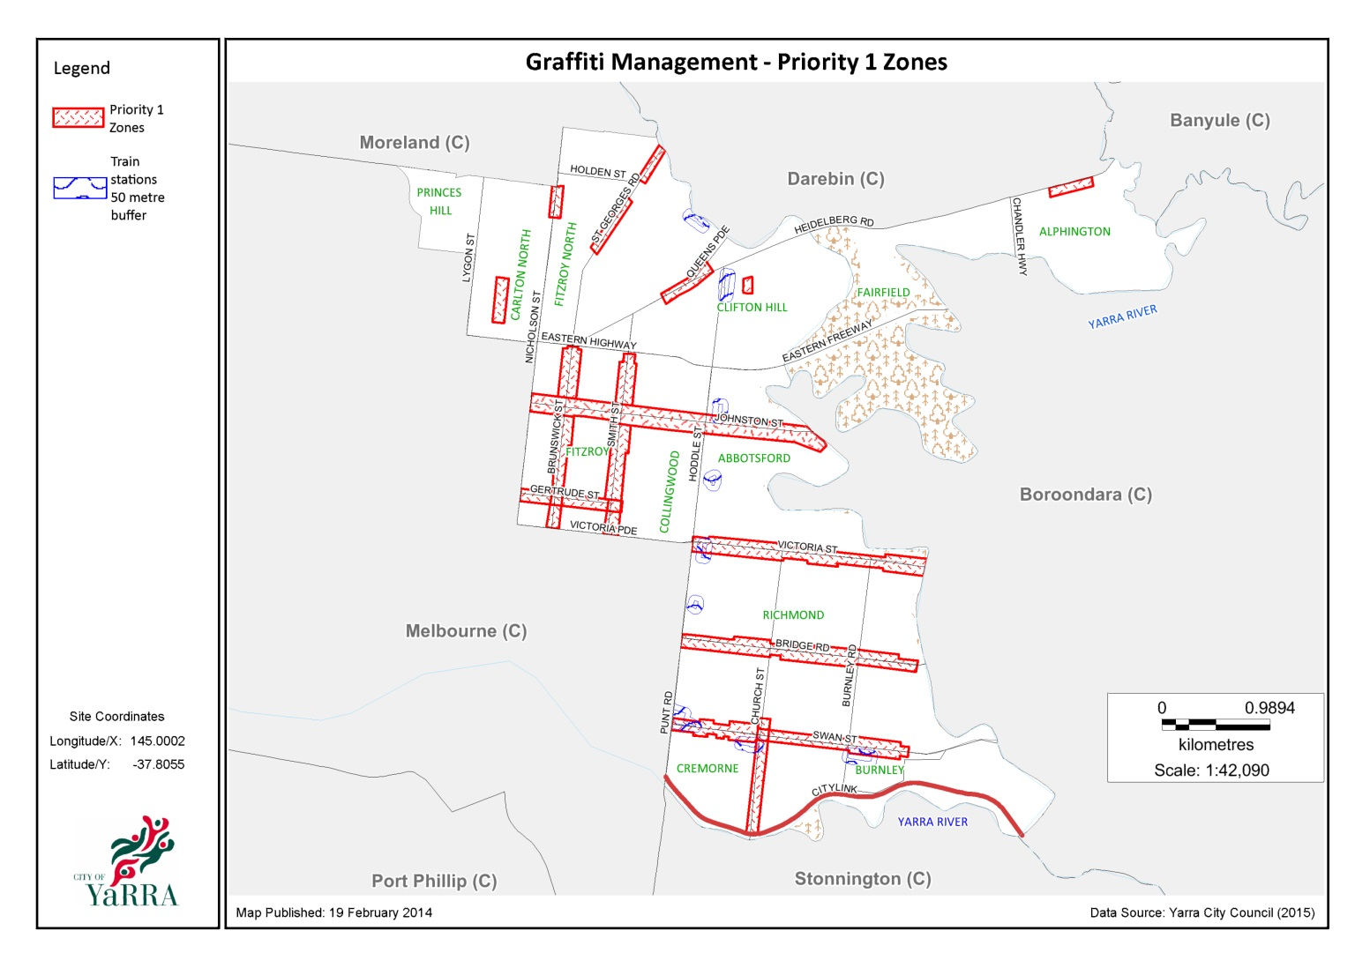

Place Management
- Across the municipality, Council will deliver place-based interventions in consultation with the community.
- Council will recognise, celebrate and cultivate the unique public art in Yarra’s urban environment.
- Council will use a range of approaches to reduce the negative impact of graffiti in public places including urban design, landscaping, and treatments.

Education & Capacity Building
- Council’s Graffiti Coordination group will contribute to effective management of public spaces, considering CPTED through statutory planning, landscaping, open space, urban design, and properties and building.
- Council will support delivery of community education, prevention, diversion, awareness and promotion programs on graffiti management including steps that residents, businesses and property owners can take to remove graffiti from private property.

Promotion
- Council acknowledges the considerable interest in Yarra’s street art and graffiti and will support its promotion where appropriate.

Planning and Enforcement
- Illegal graffiti is a criminal offence that is dealt with under the provisions of the Graffiti Prevention Act 2007.
- Council will investigate ways in which to better manage illegal graffiti.

Monitoring and Evaluation
- The Graffiti Management Framework will be advanced by active monitoring and improved through robust and strategic evaluation.
- Evidence from the evaluation will be used to plan activities, monitor and improve their implementation, make judgements about their impact and the allocation of resources.
- Council will continue to monitor best practice.

Consultation
[INSERT LIST OF STAKEHOLDERS CONSULTED WITH]

Related documents and attachments
A Graffiti Management Strategy is attached and establishes a framework for Council to respond to its own property, and to working with private and public property owners, community organisations and street artists.
The Graffiti Management Strategy is not an exhaustive list of all graffiti related activity at Yarra. Rather, it provides a means for Council to prioritise and drive forward strategies related to graffiti management and removal.
Other associated documents include:
- Yarra Youth Arts Program 2012-2015
- Arts and Cultural Strategy 2016-2020
- Council Plan 2017-2021
- Asset Management Policy 2011
- Yarra Youth Policy 2013-2016
- Public Art Policy 2015-2020
- Yarra Economic Development Strategy 2015-2020
- Yarra Heritage Strategy 2015-2018

Graffiti Management Strategy – 2019-2022
Key Result Area | Action | Responsible Unit/s | Timeline | Resources
- Graffiti Removal  Council property  Private property | 1.1 Continue removal of offensive graffiti (defamatory or degrading remarks or graphics about race, religion, sex or personal privacy) from Council property within 4 hours of notification | City Works | Ongoing | Existing
 | 1.2 Continue removal of inoffensive graffiti from Council property as soon as possible within operational scheduling | City Works | Ongoing | Existing
 | 1.3 Respond to service requests within 24 hours and where appropriate remove of graffiti from private premises as soon as possible within operational scheduling | City Works | Ongoing | Existing
 | 1.4 Continue removal of graffiti from Council assets including road signs, street furniture and bollards | City Works | Ongoing | Existing
 | 1.5 Create a workflow and process that eliminates delaying the removal of graffiti and posters in retail strips due to requiring permission of the property owner | City Works | Year 1 | Existing
 | 1.6 Continue removal of graffiti from street litterbins and park assets including playgrounds, furniture and signs | Open Space, City Works | Ongoing | Existing
 | 1.7 Continue removal of graffiti and posters from all surfaces in high profile retail strips | City Works | Ongoing | Existing
 | 1.8 Continue to fund designated positions to identify, audit and carry out clean-up work throughout retail precincts and commercial gateways across Yarra | City Works | Ongoing | Existing
 | 1.9 Utilise the Department of Justice Graffiti Removal Services where applicable | City Works | Year 1 – 4 | Existing
 | 1.10 Implement and evaluate a process to assess the criteria for removing graffiti from private property | City Works | Year 1 | Existing
 | 1.11 Seek to establish relevant MOUs with other authorities /asset owners where required to allow ongoing removal of graffiti | City Works | Year 1 | Existing
 | 1.12 Establish workflows that focus of proactive removal and prevention rather than reactive removal | City Works | Year 1 | Existing
 | 1.13 Continue to provide free graffiti removal kits and discount paint vouchers to local residents | City Works | Ongoing | Existing
 | 1.14 Carry out collaborative quick removal trials with the community to identify the most effective methods of minimising graffiti | City Works | Year 1 | Existing
 | 1.15 Investigate the feasibility of entrepreneurial and innovative solutions/enterprises for removal and treatments of graffiti and tagging e.g. fee for service | Youth Services | Ongoing | Existing
 | 1.16 As part of Council’s community grants program, fund community-based initiatives that seek to reduce the impact of graffiti | Community Partnerships | Ongoing | Existing
 | 1.17 Develop and maintain a quality assurance process to monitor graffiti removal and associated costs | City Works | Year 1 | Existing
 | 1.18 Promote the implementation of the Graffiti Management Framework | City Works | Ongoing | Existing
 | 1.19 Access Yarra will encourage the community to report graffiti to the organisation responsible for the assets via the Council website | Access Yarra | Ongoing | Existing
2. Place Management  Implement Place Based  Interventions  Engage the Community  Alternative Treatments | 2.1 Identify opportunities to implement place management strategies for illegal graffiti hotspots and places with emerging graffiti issues. | City Works, Recreation & Open Space, Asset Management, Urban Design, Arts & Culture, Youth Services | Ongoing | Existing
 | 2.2 Conduct programmed graffiti removal in retail precincts in partnership with business and property owners | City Works | Ongoing | Existing
 | 2.3 Continue to use alternative treatments such as traffic signal boxes and murals as diversionary/early intervention/prevention strategies and for precinct amenity improvement. | City Works, Arts & Culture, Youth Services | Ongoing | Existing
 | 2.4 Develop a process for implementation and oversight of treatments including consideration of an external working group to manage this | City Works, Arts & Culture | Year 1 | Existing
- Education & Capacity Building  Strategically Coordinate Graffiti  Deliver Community Education  Create Civic Pride | 3.1 Continue to strategically coordinate graffiti based projects across Council and good management of public spaces, through the Graffiti Coordination Group | City Works | Ongoing | Existing
 | 3.2 Continue to plan, develop and deliver a youth-led treatments, stencil and mural projects that enhance young people’s engagement, health and wellbeing | Youth Services | Ongoing | Existing
 | 3.3 Identify a suitable site for, and implement, a legal graffiti site within the municipality | City Works, Youth Services | Year 2 | Existing
 | 3.4 Work in partnership with local organisations to build capacity around graffiti education/awareness | Youth Services | Ongoing | Existing
 | 3.5 Regularly update and maintain graffiti-related information on Council’s website | City Works, Advocacy & Engagement | Ongoing | Existing
 | 3.6 Provide advice and information to residents on commissioning of murals on private properties | Arts and Culture | Ongoing | Existing
 | 3.7 Provide advice and information to property owners on graffiti removal and prevention in heritage areas | Access Yarra / Strategic Planning (Heritage) | Ongoing | Existing
 | 3.8 Implement community education programs such as information workshops on graffiti management | City Works | Ongoing | Existing
 | 3.9 Create a culture of civic pride to encourage residents to remove graffiti from private property | City Works | Year 1 - 4 | Existing
- Promotion  Leverage Social Media  Support & Advocate | 4.1 Leverage social media to identify, document and promote legal graffiti and street art within Yarra | Advocacy Engagement & Media | Ongoing | Existing
 | 4.2 Support and advocate for significant street art, both historical and contemporary, including commissioning and scoping preservation and restoration with stakeholders. | Arts & Culture | Year 1 – 4
- Planning & Enforcement  Better management | 5.1 Regularly update Victoria Police with information on illegal graffiti incidents such as tagging | City Works | Year 1 - 4 | Existing
 | 5.2 Investigate technology that will assist with monitoring and prevention | City Works | Year 1 | Existing
 | 5.3 Investigate the use of local laws as a tool to manage graffiti on building sites, abandoned buildings, and private property if appropriate | City Works, Compliance | Year 1
- Monitoring & Evaluation | 6.1 Council will undertake evaluations of projects as required | City Works, Arts & Culture, Youth Services | Ongoing | Existing
 | 6.2 The Coordination Group will undertake timely reviews of the Policy and report to Council on the results | City Works | Ongoing | Existing
 | 6.3 Council will investigate the best means of improving a ‘live’ register of legal street / public art installations and introducing a prospective register of treatments | Arts & Culture, City Works | Ongoing | Existing

