City of Yarra Car Share Policy 2018-2023

Objectives
The objectives of the Car Sharing Policy are to increase the use of car sharing in the City of Yarra, and ensure that the expansion of the car share network within the City is well-governed and transparent.
Specific objectives include:
- Reducing the need for car ownership. The cost of using car share services is more competitive than owning a car when the car is only used occasionally. This is particularly relevant for households with two or more cars where car sharing services could negate the need for ownership of more than one vehicle.
- Increasing sustainable transport (walking/cycling/public transport) trips. For many trips the cost of sustainable transport becomes more competitive than car share trips, with car share trips only being used for some occasional travel.
- Using on-street parking spaces more efficiently. By reducing parking demand created by underutilised private vehicles.
- Reducing vehicle traffic, noise and greenhouse emissions. By reducing vehicle kilometres travelled and shifting travel to more fuel efficient vehicles.
- Increasing social inclusion. By enabling households that cannot afford to own a car convenient access to a motor vehicle when needed.
- Supporting the local economy. By reducing household expenditure on transport and increasing a household’s disposable income. People with low motor vehicle use are less likely to drive to where they spend their money and more likely to shop locally.
- Increasing travel choice. A convenient easily accessible car share network fills the mobility gap for journeys that cannot otherwise be made by walking, cycling or public transport.

Background

Purpose
The purpose of this Policy is to:

Define the anticipated benefits of car share to the local community and Council;

Facilitate the gradual and incremental expansion of car share across the municipality between 2018 and 2023;

Provide clear targets for expanding the number of car share vehicles (on and off-street) in the City of Yarra by 2023 to create a shift towards sustainable travel choices;

Outline the rationale for any applicable fees and charges;

Outline the criteria for the preferred location of on and off-street car share bays; and

Provide a clear basis for Council procedures in how Council Officers increase the number of car share vehicles and coverage across the municipality.

Scope

The operation of car share on the road network within the municipality, including expanding the network of vehicles and any on-street parking controls; and

Increasing the provision of off-street car share vehicles, including appropriately located and designed vehicle bays within new developments through the planning application process.

References

Car Share is supported by the Municipal Strategic Statement as outlined in Clause 21.06 of the Planning Scheme by the following objectives:
- Objective 32: to reduce reliance on the private motor vehicle.
- Objective 33: to reduce the impact of traffic.

The 2018 Planning Scheme Rewrite will also give consideration to encouraging the inclusion of car share provisions in new major developments.

Car share delivers on Objective 7 of the Council Plan 2017-2021 “City of Yarra, a place where connectivity and travel options are environmentally sustainable, integrated and well-designed”. Car sharing directly aligns with this Objective as it enables people who only need a car on an occasional basis to rent one rather than own one.

Car share is supported by Action 7.11 of the Strategic Transport Statement 2012 which notes that Council will “Continue to support car sharing schemes in Yarra”; and the Principle 14 of the Parking Management Strategy (2013-2017) which notes that Council “Support and encourage households to use car share schemes” as a means of reducing parking demand within the municipality.

Definitions

Fixed Base Car Share Schemes are car share schemes in which users must return a car share vehicle to the designated parking bay from which the vehicle was initially taken.

Car Share Providers (CSP) are businesses which apply for fixed location car share bays and provide vehicles for their members to use.

On-street car share bays refer to dedicated parking spaces located on local or arterial roads which are occupied by a vehicle provided and managed by the respective Car Share Provider.

Off-street car share bays refer to parking spaces in privately owned off-street car parks, residential or commercial buildings or properties.

Exclusions

This Policy only applies to commercial Fixed Base Car Share Schemes. Peer-to-Peer Car Share Schemes are excluded from this Policy except for the purposes of promotion.

Dockless car share schemes are excluded from this Policy as such schemes are dependent on the car share vehicles being able to park in any available parking space rather than in a space designated for car share.

This Policy does not apply to any Agreement between Car Share Providers and a third party entered into for the purposes of providing a car share vehicles within privately owned property.

Council Policy

Benefits of Car Share to the City of Yarra

Independent research indicates that one car share vehicle in urban Melbourne can replace between 7-10 privately owned vehicles thereby reducing congestion and parking demand.

The research further indicates that when car ownership is replaced by an immediate and convenient access car share service that the local community become users of the service and cut their total vehicle use by 15-50%, switching trips (previously made by cars) to public transport, walking and cycling.

Car share generates a number of secondary benefits and opportunities. These include social equity as people can access a vehicle without owning a vehicle, increased physical activity, greater local expenditure, and better environmental performance through less vehicle emissions.

Targets for the Number of Car Share Spaces and Membership in 2023

There are 152 car share bays in Yarra (inclusive of 27 off-street bays) provided by three commercial Car Share Providers.

Two future car share provision options are provided in this document as part of the consultation process. These are as follows:

- Car share provision number 1 (lower): Council seeks to realise a network 231 car share vehicles (both on and off-street) across the municipality by 2023. This will provide 1 car share space per 428 residents.

- Car share provision 2 (higher): Council seeks to realise a network 283 car share vehicles (both on and off-street) across the municipality by 2023. This will provide 1 car share space per 349 residents.

In order to minimise the impact of car share parking bays on the limited on-street car parking supply, CSPs must provide one new off-street car share parking bay (occupied by a suitable car share vehicle), for every two new car share bays allocated on-street under either option.

Assuming an incremental expansion of the car share bay network to 2021, the expansion pattern is shown in Table 1.

Table 1: Proposed Annual Expansion for the Car Share Network
Car share provision number 1 (lower): | 2017-2018 | 2018-2019 | 2019-2020 | 2020-2021 | 2021-2022 | 2022-2023
New On-Street created per annum |  | 11 | 11 | 11 | 10 | 10
New Off-Street created per annum |  | 6 | 5 | 5 | 5 | 5
Total Number of Car Share Vehicles in Service | 152 | 169 | 185 | 201 | 216 | 231
Car share provision 2  (higher): | 2017-2018 | 2018-2019 | 2019-2020 | 2020-2021 | 2021-2022 | 2022-2023
New On-Street created per annum |  | 22 | 22 | 11 | 10 | 20
New Off-Street created per annum |  | 8 | 8 | 10 | 10 | 10
Total Number of Car Share Vehicles in Service | 152 | 182 | 212 | 233 | 253 | 273

Council reserves the right to amend the targets upwards or downwards as part of the mid-policy review to be completed in 2020. Any amendments to targets will consider changes to private vehicle ownership levels, the levels of car share utilisation, membership per vehicle and the benefits of car share quantified through monitoring and reporting data supplied by the CSPs to Council.

Council will work with car share operators to promote car share and increase memberships in car share schemes through promoting the concept of car share through its sustainable transport and parking compliance communications.

Car Share as a Travel Choice for Our Community

Council recognises that car share is a sustainable travel choice for the local community. In order to be a viable travel choice and an alternative to private vehicle ownership, Council seeks to create a network of car share vehicles that provide municipality wide coverage.

Council intends for the expansion of the network of car share vehicles to grow outward from the existing vehicle locations into other parts of the municipality to achieve coverage across the City of Yarra. Into the future expansion of car share will be considered through an area-by-area approach.

An analysis of the capacity for expansion of the car share network in different areas was completed and considered the following factors:
- population forecasts;
- car ownership levels; and
- levels of parking demand across the municipality.

The proposed distribution of car share vehicles across the Small Census Areas in Yarra under each scenario are outlined in Figure 1.

Figure 1: Distribution of Current and Proposed Car Share Vehicles by Small Census Areas

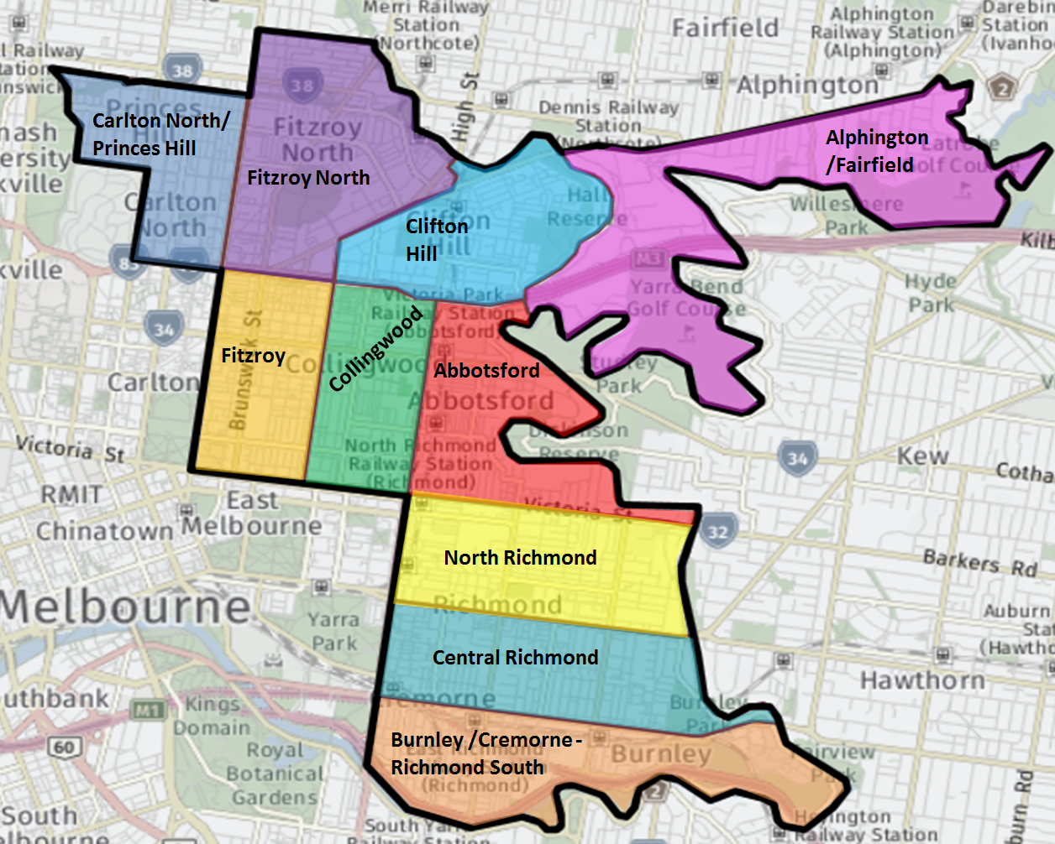

 | Existing car share spaces | Additional car share provision 1 (lower): | Additional car share provision 2 (higher):
Abbotsford | 15 | 8 | 14
Alphington /Fairfield | 0 | 10 | 13
Burnley and Cremorne - Richmond South | 8 | 3 | 6
Carlton North/ Princes Hill | 10 | 10 | 15
Clifton Hill | 7 | 7 | 11
Collingwood | 18 | 2 | 7
Fitzroy | 34 | 0 | 0
Fitzroy North | 23 | 7 | 15
Central Richmond | 21 | 13 | 21
North Richmond | 16 | 19 | 29
TOTAL | 152 | 79 (net 231) | 131 (net 273)

Base Map sourced from GoogleMaps

Siting and Location Criteria for On-Street Car Share Bays

Council’s Parking Management Strategy (2013-2017) includes Council’s Parking Hierarchy which is used by Council Officers to help steer decisions about the allocation of on-street parking and kerbside space. The hierarchy identifies two land use categories – Shopping Strips and Other Streets. The hierarchy identifies which user groups the Council should cater for first or as a higher priority. In locating new on-street car share bays consideration must be given to the relevant Council Parking Hierarchy.

Car Share Spaces on or near Shopping Strips.
The following criteria must be used when locating and siting a new on-street car share bay on or near a Shopping Strip:
- Metred parking spaces are not to be converted to car share spaces as these spaces are in high demand. Suitable locations in nearby unmetered parking areas are to be instead considered.
- Bays should be placed near intersections where possible to maximise the access catchment.
- Spaces that are no longer required and can be repurposed should be considered (loading zones or taxi bays).
- Locations where works have created new space, for example redundant vehicle cross-overs or relocated street furniture should be used.
- Ideally bays should be located at the beginning or end of a parking row.
- Spaces should not be located outside business frontages unless other options are not available, for example spaces could be located adjacent to public open space or a municipal building.
- Co-location (multiple bays in the same location) of car share bays is not encouraged unless warranted by user demand.

Car Share Spaces on Other Streets.
The following criteria must be considered when locating and siting a new on-street car share bay on Other Streets not covered by the Shopping Streets category; these streets are predominantly residential streets:
- Consideration will be given to existing car parking demand when siting a bay on a residential street. A bay will be located on a nearby residential street if the existing car parking demand on the street nominated by the CSP is deemed to be excessively high.
- Aim to place bays within 200 to 400m of each other to provide a reasonable level of coverage.
- Place bays near intersections where possible to maximise the access catchment.
- Ideally bays should be located at the beginning or end of a parking row.
- Use spaces that are no longer required and can be repurposed, for example, redundant residential disabled parking bays.
- Make use of locations where works have created new space, for example redundant vehicle cross-overs or relocated street furniture.
- Spaces should not be located outside residential frontages unless other options are not available, for example spaces could be located adjacent to a park, reserve or other Council facility.
- Co-location (multiple bays in the same location) of car share bays is not encouraged unless warranted by user demand.

Supporting the Provision of Off-Street Car Share Vehicles

Council supports the provision of car share vehicles within new large developments to:
- Reduce the need for car parking and car ownership within a development and lessen the impact of this on the locality.
- Complement the on-street network of car share spaces in the locality of the new development.

Within new large developments the provision of a car share scheme operated by a CSP is supported by Council along with a reduction in the number of parking spaces provided on-site.

Public access is required for all car share vehicles within each development. This necessitates careful design and placement of car share bays within developments to ensure easy access to the car share vehicle to allow for convenient use.

Supporting Innovation and Inclusion

Council supports the inclusion of Electric Vehicles within a CSP’s fleet and where possible will work with CSP to facilitate the use of such vehicles.

Council is supportive of CSP who can demonstrate the provision of accessible and affordable access to car share to people on low incomes.

Fees and Charges

Council seeks cost neutrality in providing on-street car share bays, managing the implementation of the Policy, and monitoring performance and reporting. In determining appropriate fees and charges, Council takes into consideration the following factors:
- The infrastructure costs of installing a new car share bay;
- Administration and management costs;
- Officer time dedicated to the expansion of the car share network;
- The value of the space to the community;
- Demand for on-street car share bays.

Fees and charges are subject to annual review.

The CSP must bear all costs associated with the installation of a dedicated on-street car share bay which must include the supply and installation a parking sensor, two generic car share parking signs and line marking of the bay as a minimum.

Renewal

On-street Car Share Space Permits expire after 12 months, at which point they are to be reviewed.

CSPs with bays provided prior to the adoption of the Policy may continue to use existing bays for a maximum period of three (3) months after which they must apply for a permit to continue using the bay, and applicable fees and charges will apply.

Council requires that car share vehicles have a minimum utilisation rate of 5% per day averaged over one (1) month. In streets with a parking occupancy greater than 80%, the minimum utilisation rate to be eligible for permit renewal is 15%.

The following will be considered during a car share bay permit review:
- Eligibility requirements.
- Records of complaints.
- Land use and road network changes in the vicinity of the car share bay.

Cancellation

In the case of non-compliance with any of the requirements set out in this Policy, sanctions may be imposed to remedy the breach and deter further non-compliance. Sanctions, if applied will be progressively escalated and may include:
- Suspension of a CSP’s right to use one or more dedicated on-street car share spaces.
- Suspension of processing of requests for new spaces and/or requests for renewal of parking permits.
- Rescission of all spaces provided to CSP by Council.

Roles and Responsibilities

CSPs are responsible for providing documents to become qualified, as outlined in Attachment 1 and providing vehicles, membership, levels of service, regular and annual reports and maintaining vehicles as outlined in Attachment 2.

Developers and Body Corporates are responsible for meeting the requirements of the Planning Scheme, Planning Permits and ensuring the development continues to comply with the Planning Permit and Conditions relating to the car share bays within their developments. Attachment 3 outlines Council’s Location and Design Criteria for Car Share Vehicles within New Developments.

Attchment 1
- Car Share Provider (CSP) Qualification Criteria

Only CSPs that are considered suitable can apply for car share bays within the City Yarra. To determine whether a CSP is qualified they must demonstrate their compliance with the criteria detailed below.

Insurance:

The CSP must hold a current Public Liability Policy of Insurance for the sum of ten million dollars.

The CSP must provide the Council with a certificate of currency in respect of the insurance/s referred to above.

Car Share Vehicle Requirements:

Providers must supply a range of vehicles based on an assessment of local needs, encompassing passenger vehicles, wheelchair capable vehicles, and vans and utility vehicles.

There is to be no third party advertising placed on car share vehicles unless by prior agreement for a specific purpose such as to offset the costs of wheelchair accessible vehicles. The CSP’s branding must be readily distinguishable for enforcement purposes.

All passenger vehicles must have a minimum 4 star ANCAP safety rating. Average emissions for passenger vehicles of 175 grams per kilometre in 2019 reducing by 15 grams per kilometre annually to 115 in 2023.

In the case of vans or utility vehicles, the operator must demonstrate that the vehicle is a high environmental performer for its class.

The vehicle must not be a caravan, box trailer and must not exceed 4.5 tonnes gross weight.

Car Share Membership Requirements:

There are to be no restrictions to membership based on the age of car share members.

As defined in VicRoads’ Traffic Management Note No. 28:
- A car share vehicle is for the exclusive use of car share members.
- A member of a car share scheme is a person who has fulfilled membership requirements with a CSP.

Vehicles are available to car share members only. There are to be no casual memberships made available as is the case with hire car companies:

Minimum Level of Service:

Car share vehicles will be available for a minimum booking period of one hour.

CSPs must ensure that no on-street space remains empty for a period greater than two consecutive days, unless by prior written agreement.

A CSP must ensure vehicles can be booked via both an internet and/or telephone booking service available 24 hours a day, 7 days a week and must provide a customer support service during business hours seven days a week.

The CSP must be capable of demonstrating they comply with the obligations set out in Attachment 2 of this policy.
Attchment 2
- Obligations of Car Share Providers (CSP)

Promotion:
Each CSP is solely responsible for the promotion of their service to prospective and existing members. Council will continue to promote the concept of car sharing as a travel choice that complements walking, cycling and public transport travel and an alternative to a privately owned vehicle through its sustainable transport communications.

Reporting:

Council requires CSPs to collect usage information on their individual car share vehicles and bay locations as well as general membership characteristics for reporting purposes.

CSPs will agree to report annually (in an accessible Excel spreadsheet) on the following characteristics for each on-street and off-street vehicle by Small Census Area:
- Total number of hours booked per month.
- Total number of trips per month.
- Utilisation rate per month (number of hours the vehicle is booked per month/time vehicle is available per month).
- Total distance travelled per month.
- Average trip distance per month.
- Number of trips over 50km per month.
- Number of trips undertaken on weekdays per month.
- Number of trips undertaken on weekends per month.
- Average emissions of passenger vehicle fleet.
- Membership numbers per month.
- Percentage growth in membership by month.
- Breakdown of members by private or corporate membership by month.
- Geographical location of members within the City of Yarra.

In addition to submitting annual reports, CSPs will agree Council can request a report at any time on the usage characteristics of any bay if required.

CSPs will agree to conduct an annual survey of Yarra members’ travel habits and car ownership levels with the results to be provided to Council.

Maintaining Car Share Location:

The CSP must supply a vehicle to the approved bay within two working days of installation.

Council’s Compliance and Parking Team is responsible for maintaining signage and line marking of the car share bay, however the CSP must ensure that:
- Maintaining or cleaning car share vehicles will not occur on-street, and no refuse shall be disposed onto the street.
- No existing or approved structures, fixtures or fittings shall be altered or added to without written approval of Council.
- Any approved fixtures, such as information panels, are kept in good condition and the information they contain is kept up to date by the CSP.

Parking Car Share Vehicles in Areas with no Parking Restrictions:

Demand for on-street parking in the City of Yarra is high. CSPs must not locate car share vehicles in areas with no parking restrictions, all car share vehicles must be located in a dedicated (sign-posted and marked) car share parking bay.

Enforcement Procedure:

Demand for on-street parking in the City of Yarra is high. Car Share Providers need to adhere to the following procedure should they find a car share bay to be illegally occupied by a non-car share vehicle:

Step 1: CSP Notification of an Illegally Parked Vehicle
- Members must immediately inform the CSP if a non-car share vehicle is parked in the car share bay and provide them with the offending vehicle’s registration details.
- Members should then park the car share vehicle legally. As close as possible to its designated bay observing clearways, disabled bays, and permit and timed restrictions, and inform the CSP of its whereabouts.

Step 2: Council Notification of an Illegally Parked Vehicle
- The CSP is to notify Council’s Parking Enforcement team, via the Customer Service Centre’s general contact number within 1 hour of being notified, and provide them with the location of the offending vehicle and its registration details as well as the location of where the car share vehicle was parked. The CSP must advise the member to park the vehicle within the City of Yarra.

Step 3: Infringement of Illegally Parked Vehicle
- Parking Enforcement will respond to requests to infringe illegally parked vehicles subject to standard operating procedures.
- The CSP will be liable for payment of infringement notices associated with illegally parked car share vehicles.

Step 4: Returning the Car Share Vehicle to the Car Share Bay
The CSP must ensure that the car share vehicle is returned to the car share bay.

Allowing Access to Car Share Bays:

The CSP will grant Council access to the bay for necessary activities such as line marking, road works, festivals or events. Council will aim to provide advanced notice to the CSP in these situations.

Failure to Meet Obligations:

Council can suspend the CSP’s right to use one or more of the allocated car share spaces if they fail to meet any of the obligations listed above and can choose to reallocate bays to another CSP.

Attchment 3
- Location and Design Criteria for Car Share Vehicles within New Developments

Location and Design Criteria Guidelines:

The below criteria provide guidance to the location and design of car share bays within new developments:
- The car share space must be accessible 24 hours a day, seven days a week by any member of the car share provider, and by employees or contractors of the car share operator in order to clean, detail or service the car.
- A highly visible location from the street:
  - for buildings with car parks in the front setback, in the front set back of the site adjacent to visitor car spaces.
  - for buildings with car parks at the rear, at the rear of the site adjacent to visitor car spaces or loading facilities.
- Ideally in front of boom gates.
- In the first level of a multi-storey car park (be it ground level, the first level up or first level down).
- In a separate location to where other, assigned / subdivided car spaces are provided.
- Where security arrangements are not required or are simple to follow (and where customers can use the same mechanism that they use to get into the vehicle).
- In a well-lit part of the site.
- A short distance from an entry point, lift or staircase.
- In a standard car space where manoeuvring in and out of the space is limited to no more than three movements.
- On common property managed by the Owners’ Corporation.
- Minimum height clearance of 2.2 m to allow a cleaning van to enter, manoeuver and exit.
- Mobile data and GPS reception.
- Markings for exclusive use of the car share vehicle.
- The establishment and operation of a car share space must occur soon after completion and before 20% occupation of the development.

As outlined in the “Research for the City of Port Phillip’s Car Share Policy Review” Report, dated February 2016, prepared by Phillip Boyle & Associates for the City of Port Phillip.
VicRoads Traffic Management Note No. 28 – Guidelines for the Implementation of Car-Share Parking, November 2009.

