Gambling Policy
City of Yarra
Social policy and research, city strategy
2016
Contents
Glossary 1
1. Executive Summary 3
2. Preamble 3
3. Background 4
3.1. Understanding the social costs of gambling 6
3.2. Changes in gambling platforms 7
3.3. Expenditure on poker machines in Yarra 8
3.4. Council actions to addressing gambling harm 12
3.5. Yarra Gaming Strategy: A Community Wellbeing Approach (2011 – 2015) 12
3.5.1. To enhance Council’s regulatory role 13
3.5.2. To support informed choice 13
3.5.3. To seek collaborative relationships 14
3.5.4. To foster social inclusion 14
3.5.5. To develop clear advocacy positions 15
4. Policy 2016 15
4.1. Policy Goals 17
Endnotes 20

Tables and Figures
Table 1: Venues, Poker machines and expenditure (July 2015 – June 2016) 8
Figure 1: How Australian’s gambling expenditure compares to other public health issues…………. 5
Figure 2: How the harm caused by gambling impacts on individuals and the wider community. (Source: Kings Community Action Group on Gambling) …………………………………………………………………..5
Figure 3: Proportion of gambling-related harm in the Victorian gambling population by risk category (Browne et al 2016) 7
Figure 4: Venues and numbers of Electronic Gambling Machines in the City of Yarra and in surrounding municipalities 10
Figure 5: Annual Poker Machine Expenditure Yarra (2010-2016) Source- VCGLR 11
Figure 6: Monthly Poker Machine Expenditure Yarra (July 2014 - June 2016) 11

Glossary
Alliance for Gambling Reform (AGR) – is a collaboration of organisations with a shared concern about the deeply harmful and unfair impacts of gambling and its normalisation in Australian culture. It campaigns for reforms of the gambling industry that reduce the harm it causes. Its campaign includes education about the way Electronic Gaming Machines are designed to mislead people into believing they can win, when the machines are weighted to mean that the user is more likely to lose, including false ‘near misses’ and losses disguised as wins. Each machine is also designed to take up to $1200 per hour, making them an unreasonably high gambling technology. The Alliance is currently preparing a legal case in the Federal Court arguing they are breaching consumer law.
Electronic Gaming Machines (EGMs) – also known as pokies or poker machines, are controlled by a computer program that generates thousands of combinations every second. To place a bet on a poker machine you must insert cash into the machine and press the button. The machine will determine the position of symbols on the game and generate one outcome. If the machine determines a win, credits are paid. If not, the machine continues to generate outcomes until the button is pressed again.
At 30 June 2015 there were 28,892 poker machines in Victoria located amongst 506 clubs and hotels, and the single licensed casino provider – Crown Casino. No venue apart from Crown Casino is permitted to have more than 105 poker machines. The machines are owned and operated by the local venue. Venue operators must apply to the VCGLR for a license to operate poker machines and to their local council for a planning permit.
Gambling - The following forms of gambling are legal in Victoria: poker machines, casino games, wagering, sports betting, Keno, lotteries and bingo. All of these forms of gambling are regulated in Victoria.
Net detrimental social and economic impact –refers to the likely negative impacts or consequences of a planning proposal. Council has to prove that the proposal will lead to negative consequences for the community which outweigh the benefits proposed by the introduction of additional machines or venues.
SEIFA (Social Economic Index for Areas) – is a product developed by the Australian Bureau of Statistics that ranks areas in Australia according to relative socio-economic advantage and disadvantage, based in information from the five-yearly Census.
Victorian Commission for Gambling and Liquor Regulation (VCGLR) – is an independent statutory authority authorised to regulate gambling in clubs, hotels and the Crown Casino as well as sports betting and wagering. Gambling businesses or activities need the VCGLR’s permission to operate in Victoria. It reports to the Minister for Liquor and Gaming Regulation.

Executive Summary
This policy build upon the ‘Yarra Gaming Strategy: A Community Wellbeing Approach 2011-2015’. It recognises that the community harm resulting from gambling is wide spread and that local Councils have a clear role in creating a safe environment for its residents.
The number of Electronic Gaming Machines (EGMs or poker machines) in Yarra has remained static since the last policy. Yarra has a clear local policy that regulates where EGMs are to be located which limits their proximity to areas of social and economic disadvantage.
This policy promotes a vision:
TO ADVOCATE FOR A FAIRER SOCIETY WHERE THE GAMBLING INDUSTRY NO LONGER CAUSES SOCIAL AND ECONOMIC HARM IN THE COMMUNITY OF YARRA.
It has the following main goals:
- Advocacy to reduce the number of poker machines in Yarra
- Support gambling-free community activities
- Improve community understanding about the risks posed to the community by the gambling industry
- Reform of the gambling industry
- Enable community participation in planning decisions concerning gambling activities

Preamble
There has been a shift in thinking about Electronic Gaming Machines (poker machines) over the past few years. This new policy is therefore an update on Yarra Council’s 2011-2015 Gaming Strategy to refresh and refocus the efforts of Council on this topic. Rather than seeing poker machines as a legitimate recreational activity that has negative impacts on only a small number of ‘problem gamblers’, many local councils now see it as an industry that deliberately misleads users and creates an unacceptable risk of harm to the whole community. New knowledge about how poker machines are designed demonstrates that industry-based self-exclusion measures to enable ‘responsible gambling’ are only window-dressing solutions to a wider problem. It is the industry itself which is creating the problem. This is the message of the Alliance for Gambling Reform, a national collaboration of organisations with a shared concern for the harmful and unfair impacts of gambling. Yarra is a proud member of this Alliance. The documentary, ‘Ka-Ching Poke Nation’ is now being screened across the nation as an advocacy tool and a trigger for community debate and awareness about the ways the poker machine industry manipulates users to maximise losses.
- Australians spend more on gambling per person than any other country in the world and have 20% of the world’s poker machines despite having 0.3% of the world’s population.
- The various governments across Australia receive $5.5 billion in taxes each year from the gambling industry.
- Victorians spent $2.6 billion on poker machines from July 2015 to June 2016, up by $44.7 million from the previous year.
- The biggest losses come from some of the state’s most disadvantaged areas, such as Brimbank, Casey, Dandenong, Geelong and Whittlesea.
- For every $100 spent on poker machines, the Victorian government receives $34.90 in taxes.
Yarra’s new policy is focused on limiting community access to gambling, especially poker machines. The policy positions will also aim to reduce the harm caused by other gambling activity, such as online sports betting and other gambling platforms.
Yarra Council is strongly committed to managing and minimising the negative impacts of gambling and joining its voice to demands for reforms to the gambling industry. Its primary focus is on reforms to the poker machine industry. This policy statement will guide further Council actions in Yarra’s ‘Health and Wellbeing Plan 2017-2021’.
Council acknowledges that local government is the responsible authority for protecting and promoting the health and wellbeing of communities. It is also responsible for developing and enforcing a local planning scheme that provides direction for decisions related to the location of Poker machines in their municipality. The focus of Council’s work is continue to restrict access to poker machines and to advocate to government for reforms that will minimise the harm caused by existing machines.

Background
During the past four decades, governments around the world have progressively reduced legislative restrictions on gambling which has had the effect of increasing their acceptance as a recreational past-time. The majority of the 200,000 electronic gambling machines in Australia are located within hotels, sports and recreations clubs, placing them at the heart of local communities.
Since the introduction of electronic gambling machines (poker machines) in 1992 and the establishment of Crown Casino in 1994, the scale and scope of gambling in Victoria has rapidly expanded. The culture of gambling has become no normalised in Australia that Australians spend more on gambling than other activities recognised as addictive, such as alcohol, tobacco and all illegal drugs. Across Australia, it is now nearly three times the amount spent on illegal drugs.
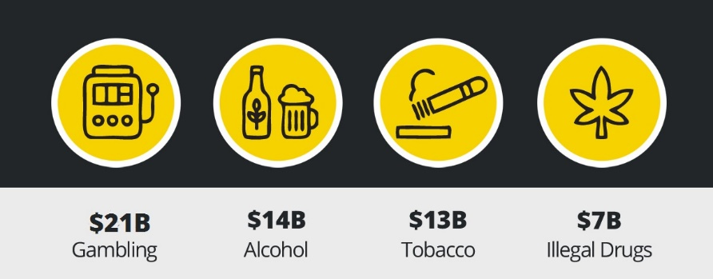
Figure 1: How Australian’s gambling expenditure compares to other public health issues. (N.B. The expenditure below in Figure 1 is for the year to March 2014) (Source: Alliance for Gambling Reform)
The Victorian Government reported that in the 2013-14 financial year poker machines raised $1.817 billion in gambling taxes, an increase from approximately $1.678 billion raised in 2012-13. Taxes on electronic gambling machines made up the majority of this revenue at 59%. Gambling taxes in 2013-14 were 10.8 per cent of Victoria's taxation revenue and 3.4 per cent of total government revenue from all sources.
These taxes are collected from an activity largely targeted at people from lower socio-economic backgrounds who can least afford to pay. Poker machines tend to be concentrated in areas of high disadvantage. For example, one of Melbourne’s most disadvantaged local government areas, Greater Dandenong, has 8.4 poker machines per 1000 residents, compared to Boroondara which has 1.5 machines per 1,000 residents. Poker machines offer hope to people facing financial and other problems, meaning that they are at risk of losses which they cannot afford.
On the other hand, their wide accessibility to all means that there can be problematic social impacts across all sections of the community – up to 160,000 Australians suffer severe gambling problems and as many as 350,000 additional people are at moderate risk. Poker machines account for 75-80% of these problematic gamers. Hence all local councils need to be aware of the wide-spread threat posed by this addictive activity and how it can impact the wellbeing of all its residents.
Poker machines usage involves large amounts of cash being lost to residents. Victorians lost $210 million in the single month of April 2015 by using poker machines. There was $2.6 million spent on machines in the City of Yarra in the same month. The amount lost in Yarra during this month in 2015 is around one quarter of a million dollars higher than the amount lost in April 2014. In the financial year of 2015-2016, over $33M was lost on poker machines in Yarra. This equates to $419 per adult each year and was an increase of 6.1% from the previous financial year. This money lost to residents has a flow-on affect that lead to social costs to families and the broader community.

Understanding the social costs of gambling
Council uses a public health approach to quantify the community impact of gambling in assessing numbers and locations of poker machines. The risks posed by poker machines are not easy to quantify compared to the benefits described by the industry. Research on how impact is measured by the Victorian Commission for Gambling and Liquor Regulation (VLGR) has found that concrete financial benefits promised by the poker machine supplier tends to be more persuasive than the poorly quantified social impact.
The impact of gambling is complex and long term.
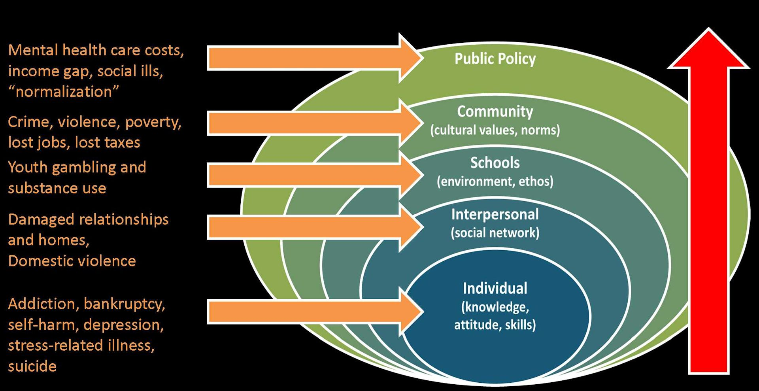
Figure 2: How the harm caused by gambling impacts on individuals and the wider community. (Source: Kings Community Action Group on Gambling)
We are getting better at understanding the social costs. We know that the social cost of gambling in Australia has been estimated at $4.7 billion every year. It is also important to recognise that gambling-related harm is spread across the whole community and not just those who could be seen as ‘problem gamblers’. Research on the gambling burden of harm suggests that problem gamblers account for only 15% of the burden of harm. There is a far wider spread of harm than previously recognised.

Figure 3: Proportion of gambling-related harm in the Victorian gambling population by risk category (Browne et al 2016)
This community burden of harm approach is different to the medical model which focuses on individual harm. This does not mean that individual distress should not be underestimated. It has been estimated that around 17% of people who present to a public mental health service may have issues with problematic gambling. Nevertheless, it has also been estimated that there may be five to ten people who face serious emotional or financial consequences for every single person who has a gambling problem. This ripple effect of gambling needs to be understood within the context of the whole community.

Changes in gambling platforms
With the rise of online gambling and the wider reach of smart phones and tablets, gambling activity is now increasingly mobile and promoted via social media. It is becoming normalised as a recreational activity. A large-scale study of the relationship between social media and gambling behaviours showed that, for a small group of gamblers, the use of social media and on-line games can trigger or exacerbate gambling problems. People who play simulated gaming machines are more likely to gamble commercially and develop problems with gambling.
Poker machines have been called the ‘crystal meth’ of the gambling industry, making up $11B of gambling-related losses and the machines are designed to manipulate people into addiction. Better consumer protection laws are required to protect people from these harms. While gambling-harm can be caused by many gambling mediums, it has been estimated that up to 1-in-6 regular poker machine users may be experiencing addiction and that three-quarters of all problem gamblers who seek assistance have problems with poker machines. Therefore it is incumbent on Councils to be mindful of these community-wide issues and to reduce their negative impact on residents.
Nevertheless, there is still overwhelming evidence that proximity to poker machines increases the risk of harm to people already facing social and economic disadvantage. Recent research has identified that high levels of disadvantage are associated with higher levels of loss at poker machines and that regulation of poker machines around areas of disadvantage needs to be improved. Despite the changes in gambling platforms, poker machines remain a major risk to the community.

Expenditure on poker machines in Yarra
There are 308 poker machines located across eight gambling venues in Yarra. The locations of poker machines mirror the locations of large pockets of social housing in Yarra. Besides these locations, many more Poker machines are located in surrounding municipalities or Darebin, Moreland and Melbourne.
Table 1: Venues, Poker machines and expenditure (July 2015 – June 2016)
Venue | Name | Address | Attached entitlements | Poker machines | Venue type | Expenditure (July 2015-June 2016)
1 | Bakers Arms Hotel | 355 Abbotsford Street, Abbotsford | 32 | 32 | Hotel | $4,441,392.47
2 | Parkview Hotel | 131 Scotchmer Street, Fitzroy North | 30 | 30 | Hotel | $2,178,137.12
3 | Punters Palace | 314 Smith Street, Collingwood | 20 | 20 | Hotel | $1,855,784.12
4 | Royal Oak Richmond | 527 Bridge Road Richmond | 80 | 80 | Club | $4,055,140.06
5 | Tankerville Arms | 230 Nicholson Street Fitzroy | 49 | 49 | Hotel | $6,287,433.20
6 | The Prince of Wales Hotel - Richmond | 109 Church St, Richmond | 40 | 40 | Hotel | $5,809.879.48
7 | Vaucluse Hotel | 157 Swan St Richmond | 31 | 31 | Hotel | $4,220.965.51
8 | Vine Hotel | 254 Bridge Road | 26 | 26 | Hotel | $4,143.618.26
 | Totals |  | 308 | 308 |  | $32,992,353.39
The Royal Oak Club in Bridge Road, Richmond is the largest venue with 80 Poker machines, under license to the Carlton Football Club, with expenditure/ losses of $4.09M in 2014-2015. The Tankerville Arms Hotel in Nicholson Street, Fitzroy had the highest expenditure/losses at $6.3M in 2014-2015 with 49 Poker machines. Hotels generally have higher expenditure than clubs because of the more liberal opening hours.
Overleaf is a map illustrating the locations of poker machine venues in and around the City of Yarra, along with the number of machines per venue and those areas designated as inappropriate locations for Poker machines under the City of Yarra Planning Scheme. Council’s Planning Scheme requires a planning permit to install or use a poker machine and the Local Gambling Policy (Clause 22.15) provides guidance for decisions in this area. It prohibits installation or use of Poker machines in strip shopping centres and in the Richmond Plaza and Victoria Gardens Shopping Centres. It also discourages the location of gambling machines in nominated areas within 500 metres of areas of disadvantage as identified using SEIFA index of relative disadvantage.

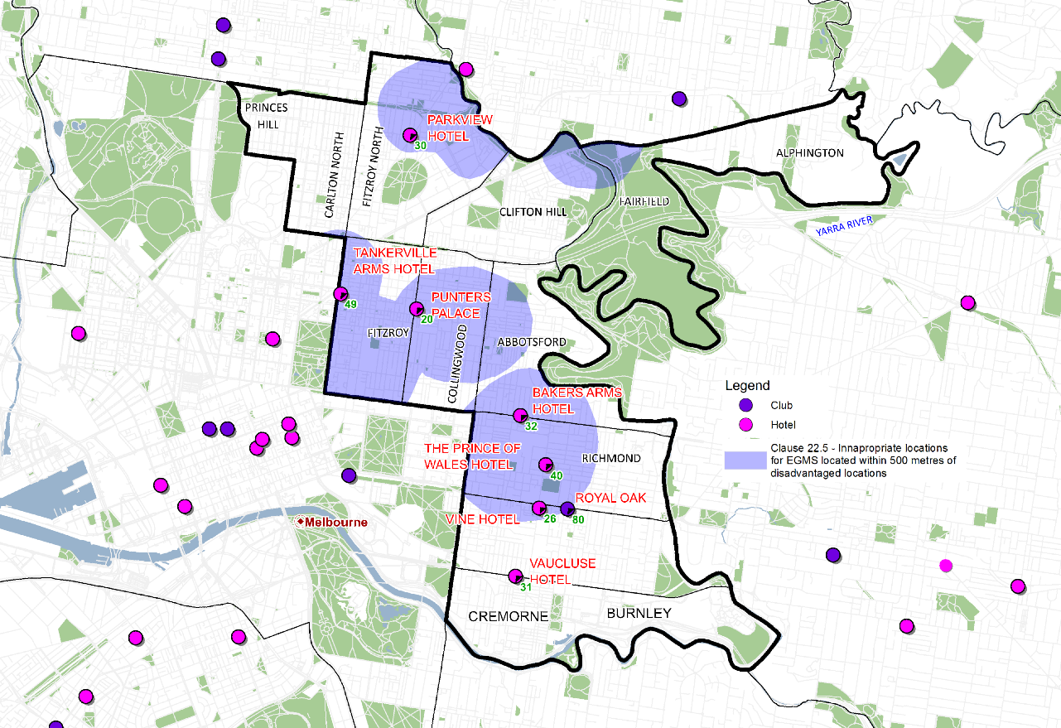
Figure 4: Venues and numbers of Electronic Gambling Machines in the City of Yarra and in surrounding municipalities, overlaid with Yarra Planning Scheme ‘inappropriate locations’.
Figure 2 below shows the trend in annual poker machine expenditure in Yarra from 2010 until June 2015. Expenditure on poker machines is the total amount lost by players on gambling machines. It is to be used to provide an accurate picture of the size of the poker machine industry in each local government area.

Figure 5: Annual Poker Machine Expenditure Yarra (2010-2016) Source- VCGLR
The expenditure on machines in Yarra was 32,992,353 in the period 2015 to 2016. This was an increase in 6.1% from 2014 to 2015 was $31,084,714.

Figure 6: Monthly Poker Machine Expenditure Yarra (July 2013 - June 2016)

Council actions to addressing gambling harm
Yarra is a socially and economically diverse community, with a large disadvantaged population living alongside some of Melbourne’s most wealthy neighbourhoods. Poker machine venues are located across the municipality. Of particular concern to Council is that poker machine venues are close to the 9% of its population living in a collector district with a Social and Economic Index (SEIFA) disadvantage index below 700. In addition, housing affordability in Yarra has been declining, creating financial stress for nearly 3,000 Yarra households, including 13% of households in Collingwood and North Richmond. Losses related to gambling can compound these financial stresses.
Council plays an important role in building social connections and community support to reduce isolation and other vulnerabilities that may contribute to poker machine addiction. Research has shown that the impact of gambling on local communities might be mitigated by the presence of other factors in the community that promote resilience, such as volunteering.

Yarra Gaming Strategy: A Community Wellbeing Approach (2011 – 2015)
In 2011, Council produced a four year strategy that adopted a community wellbeing approach in recognition of the harms posed by problematic electronic gambling not only to the individual but to the wider municipality. The strategy recognised that gambling posed a risk to some members of the community who may have particular vulnerability to gambling harm and also that people gamble for different reasons. It is acknowledged that some parts of the community do not have accurate information about gambling products, as well as about their rights and consumer protections. It also acknowledged the devastating effects of gambling on children, families and the wider economy due to the changed behaviours and spending patterns that can flow from problematic gambling. Lastly, it is accepted that many community members are broadly opposed to electronic gambling in Yarra
Given the local government policy environment in relation to gambling, included regulatory preparation and social planning, it was decided to support and expand initiatives which supported informed consumer choice and the fostering of community resilience. The Council position was ‘to minimise gambling harms in the Yarra community, advance community wellbeing, advocate for change to other levels of government and act consistently with this strategy in relation to hire, lease and use of Council facilities.’ This position remains relevant in 2016.
It is timely to review the changes that have taken place in the gambling policy area since the strategy was launched in 2011 and to acknowledge the actions that took place as part of this strategy.
In 2011, five key action areas were pursued with the following actions taken by Council:

To enhance Council’s regulatory role
Ensure planning decisions include rigorous social and economic impact assessments, recognising that the assessment process affords opportunity for community views to be considered in relation to planning decisions relating to gambling.
- No new licence application within Yarra since the Strategy was launched.
- The number of poker machines has grown in the suburbs close to Yarra and Council has actively supported its neighbouring Councils to assess the impact of these applications on the wellbeing of residents.
- Yarra residents are still able to travel to other Local Government Areas and use these machines, meaning that Council must continue to look at social and economic impacts in the wider area.

To support informed choice
Make broad community messages available stating the risks of poker machine gambling for Yarra residents, businesses and visitors, with particular focus on the needs of vulnerable groups.
- Through its Community Grants Program, Council funded a Vietnamese Women’s Alcohol and Other Drugs support group to provide education to Vietnamese women about gambling as well as other social issues across one year. The Centre for Ethnicity and Health also distribute information resources about problematic gambling in community languages and Council uses these as required.
- Council is concerned that relying on such messages is contrary to evidence that poker machines themselves are unsafe. It considers that strategies that encourage self-regulation will not solve the wider problems relating to the industry and how the machines themselves are designed to manipulate the user.
- From 1 December 2015, pre-commitment measures must be available for all gambling machines to enable players to set limits and track their usage.
- Council supports an independent evaluation of the effectiveness of these and other measures, especially for vulnerable groups, with all results being made public.

To seek collaborative relationships
Bring local stakeholders together drawing on public health and consumer protection strategies and develop collaborative relationships in order to address the harms associated with gambling.
- The Active Ageing Advisory Group collaborates with Council to raise issues of ageing in Yarra.
- The Yarra Settlement Forum regularly brings issues to the attention of Council from agencies supporting newly arrived immigrants. Such collaborative relationships mean that any issues which relate to problematic gambling can be addressed as early as possible.
- Council will continue to collaborate with local and state stakeholders on consumer protection strategies.

To foster social inclusion
Raise awareness of the services available to assist those directly affected by the adverse effects of gambling, both in the community and among stakeholders, to show leadership and to encourage and support community members to seek help.
- During Responsible Gambling Awareness Week (RGAW) in 2013 it partnered with Hume City Council on a project called ‘Young People Speak Out’ which was a short-story competition about the issue of gambling targeting young people aged 16 to 25. This generated a great deal of exposure of the issues as well as empowering young people to creatively express their own experiences and feelings about problematic gambling. It also led to a documentary for young people, parents and educators focusing on ways parents can talk to young people about gambling risks, which was developed in partnership with North East Primary Care Partnership & Gamblers Help City.
- In 2015, the March Away From Gambling campaign also saw the development of social inclusion initiatives such as the Alphington Community Centre’s games night which was designed to offer an alternative to gambling.
- Yarra recognises the limitations of this approach due to the addictive nature of poker machines.

To develop clear advocacy positions
Advocate to other levels of government regarding policy measures that seek to reduce gambling harms, support informed consumer choice and result in greater community wellbeing.
- In 2012 Yarra engaged the services of Symplan consultants to assess the implications for the community of Yarra of an application from the Grandview Hotel in Fairfield to develop 50 new Poker machines. It found that there was a net detrimental social and economic affect to the community for having these additional machines.
- Council made a submission to the Office of Liquor, Gaming and Racing ‘Gaming Machines Arrangements Review’ in 2016.
- In 2016, Yarra Council joined the Alliance for Gambling Reform and will collaborate on developing measures to reduce harm caused by the gambling industry.

Policy 2016
Yarra’s Council Plan 2013-2017 places a high priority on the liveability of the local area and recognises that Council can play a lead role in reducing social isolation and supporting community initiatives that improve the variety of alternative activities available to people. It has developed a Memorandum of Understanding with the nine neighbourhood houses in Yarra that outlines the highly-valued role neighbourhood houses play in bringing people together, especially as Yarra’s population grows and its needs change.
Yarra’s Community Grants are also part of Council’s ongoing commitment to build strong local communities and support initiatives which offer connections amongst vulnerable groups that might prevent gambling.
Council’s Health Plan 2013-2017 proposes a vision of ‘helping communities flourish through health promoting environments’. It recognises the particular health vulnerabilities of CALD groups and the need to develop options for civic and community participation as well as understanding and navigating governance systems.
In addition, Council’s Multicultural Partnerships Plan 2015-18 includes Council’s commitment to addressing the potential social isolation of Yarra residents through partnering with local community support services. This is part of a broader commitment to consider the needs of existing as well as newly arrived migrants and, where possible, to improve their wellbeing and reduce the risk of engaging in risky behaviours, including problematic gambling.
Council’s Aboriginal Partnerships Plan 2015-18 also outlines the important role for Council in facilitating local employment and promoting culturally relevant events to offer alternatives to gambling.
The policy goals and actions (listed overleaf) build upon and complement Council’s efforts in addressing the individual and societal harms of gambling and will enable Council and its partners to continue to work together to address problematic gambling in the municipality and more broadly.

Policy Goals
Vision:
‘To advocate for a fairer society where the gambling industry no longer causes social or economic harm in the community of Yarra.’
- Advocacy to reduce the number of poker machines in Yarra
Rationale:
Council views poker machines as a threat to community well-being and aims to protect its community from this threat by restricting the access to these machines as much as possible in Yarra and in the wider community.
Actions:
  - Council will oppose any applications within the City of Yarra and neighbouring municipalities which result in a net increase in the number of poker machines and cause social and economic harm to local communities.
  - Council will strongly advocate for a reduction in the number of poker machines across the wider municipality.
- Foster social inclusion in Yarra by supporting gambling-free community activities
Rationale:
Council will take a lead role in the local community by fostering positive social relationships and encouraging community activities that reduce the potential market for poker machines and.

Actions:
  - Council will continue to fund services that improve social connection and local infrastructure that provides alternative recreational activities to gambling.
  - Council will not provide grants to any community agencies for activities which are sponsored by gambling businesses or for activities which take place in gambling venues.
  - Council will not sponsor any social activities that take place in gambling venues and will encourage venues with poker machines to explore alternative means to maintain their revenue base.
- Improve community understanding about the risks posed to the community by the gambling industry
Rationale:
Council recognises that the poker machine industry has access to powerful lobbying tools. It also recognises that the machines are designed to manipulate the user. The community needs to better understand the dangers of the machines so they can make an informed choice as a consumer about whether or not to use poker machines.
Actions:
  - Council will engage in community education to raise awareness of the risks involved in the poker machine industry.
  - Council will conduct these activities in a way which meets the specific needs of women, people from a CALD background, people from an Aboriginal or Torres Strait Islander background, people with a disability and/or mental illness, and older people.
  - Council will support efforts to educate its staff about the social costs of gambling as part of its commitment to occupational health and safety.
- Reform of the gambling industry
Rationale:
Council recognises that the state government receives over 10% of its taxes from the poker machine industry. Council considers that this compromises the state government’s capacity to address the harm caused by the industry. The industry is also likely to resist any attempts to reduce its profits. A root and branch reform is the only way to break down the nexus between the poker machine industry and government. Yarra is a member of the Alliance for Gambling Reform and will work with this organisation to achieve its goals.
Actions
  - Council will advocate for industry reforms at the state and federal government levels that reduce the harm caused by poker machines via supporting mandatory pre-commitment measures and $1 maximum bets.
  - Council will advocate for the removal of machine features which are misleading and addictive.
  - Council will support other reforms that can be shown to reduce social and economic harms in Yarra and in the wider community.
  - Council will collaborate with research and data collection projects that aim to illustrate the harm caused by poker machines.
  - Council will advocate for taxation reform that taxes wealth rather than gambling.
- Enable community participation in planning decisions concerning gambling activities
Rationale:
The communities that are affected by decisions should have their say in those decisions. The Planning and Environment Amendment (Recognising Objectors) Act 2015 requires Victorian Civil and Administrative Tribunal (VACT) and Councils to consider the number of objectors to a permit application in considering the social impact of a future development.
  - Council will support and encourage members of the community to submit their views about gambling licensing applications.
  - Council will support research and data collection that demonstrates the social impact of gambling and will clearly communicate the findings of this research to the wider community.

Endnotes

http://www.pokiesplayyou.org.au/about
Victorian Commission for Gambling and Liquor Regulation.
https://www.responsiblegambling.vic.gov.au/information-and-resources/whats-new/2013/december-2013/tax-increases-on-pokers-and-changes-to-return-to-player-rates
http://www.responsiblegambling.vic.gov.au/information-and-resources/faqs/gambling-expenditure-and-taxes
Enough Pokers Position Paper, Edition 3, 17 November 2014.
http://ministers.treasury.gov.au/DisplayDocs.aspx?doc=pressreleases/2010/138.htm&pageID=&min=njsa&Year=&DocType=0
Enough Pokers Position Paper, Edition 3, 17 November 2014.
http://www.vcgr.vic.gov.au/CA256F800017E8D4/VCGLR/2C4FB00D26AF1EFFCA257B320078D3F5?OpenDocument
Charles Livingston and Louise Francis, ‘Review of Decisions by the Victorian Commission for Gambling and Liquor Regulation’, MAV and Monash University, 2014.
http://www.kingscommunityactiongroupongambling.ca/know-the-facts/gambling-harm-impacts-us-all
http://www.problemgambling.gov.au/facts/
Browne, M, Langham, E, Rawat, V, Greer, N, Li, E, Rose, J, Rockloff, M, Donaldson, P, Thorne, H, Goodwin, B, Bryden, G & Best, T 2016, ‘Assessing gambling-related harm in Victoria: a public health perspective, Victorian Responsible Gambling Foundation, Melbourne.
Anthony de Castella, Pip Bolding, Adeline Lee, Sonja Cosic, Professor Jayashri Kulkarni. ‘Problem Gambling in People Presenting to a Public Mental Health Service’, Office of Gaming and Racing, Department of Justice, 2011.
Beyond Blue, ‘Problem Gambling and Depression fact sheet’.
‘The use of social media in gambling’, Sally M. Gainsbury, Daniel King, Paul Delfabbro, Nerilee Hing, Alex Russell, Alex Blaszczynski, Jeffrey Derevensky, Southern Cross University, 2015.
Australian Gambling Research Centre Discussion Paper ‘Is it Gambling or a Game?’, April 2016.
Victorian Auditor General, ‘Audit Summary of Taking Action on Problem Gambling’, 2010.
Angela C. Rintoul, Charles Livingstone, Andrew P. Mellor, and Damien Jolley, ‘Modelling vulnerability to gambling related harm: How disadvantage predicts gambling losses’, Addiction Theory and Research, 2013, Vol. 21, No. 4 , Pages 329-338
Please note that the "Monthly Net Electronic Gaming Machine Expenditure" amount appearing above is based on data that may not have been fully audited to date. Any changes are unlikely to have a material effect on the figures provided. The data is audited on an ongoing basis during each financial year to produce the annual net expenditure amount appearing above.
ABS, ‘Census of Population and Housing’ 2011.
Office of Gaming and Racing, Department of Justice, (2011), ‘Socio-economic impacts of access to electronic gaming machines in Victoria: effects on demands and communities’

